Microsoft Dynamics CRM
Power your service productivity
World-class customer experiences start with your people. Microsoft Dynamics® CRM business software arms your customer service professionals with a customer service and support solution that combines the power of productivity with ease of use. Users can take advantage of a wealth of features like case management, workflows, dashboards, and knowledge management right within the Microsoft® Outlook® client so they can work in a way that is natural and personal to deliver consistent, fast, and efficient service.  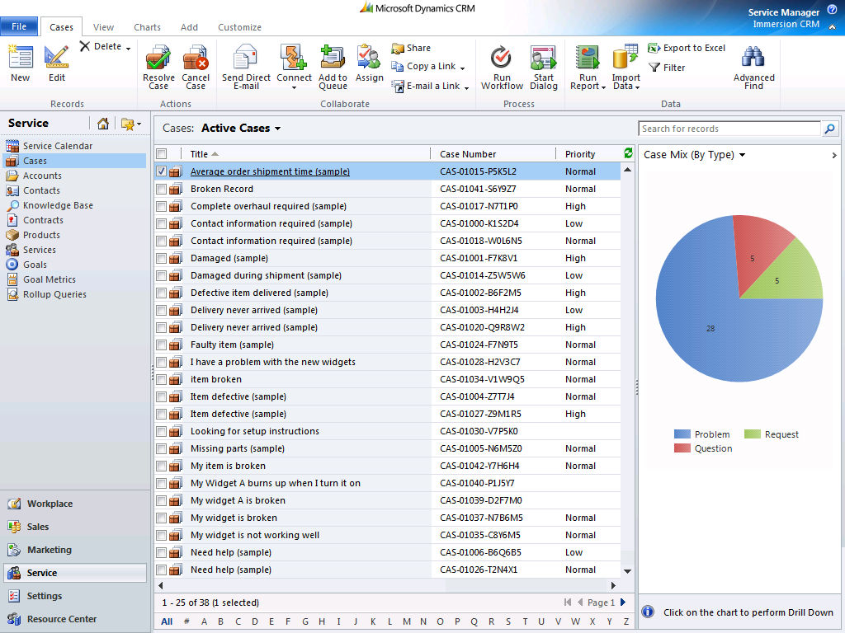  Streamline case resolution using an intuitive user interface that simplifies common tasks and provides powerful inline data visualization capabilities that turn data into actionable insight. | Become a Dynamic Business  Your People: Boost Service Productivity  People want access to tools that are familiar, easy to use, and purposeful. With the familiar Microsoft Outlook interface, role-based forms, and embedded Microsoft Office features, Microsoft Dynamics CRM minimizes administrative tasks and gives your customer service professionals more time to focus on their core competency—servicing customers.  Your Processes: Drive Service Efficiency  Processes that are efficient and consistent help drive higher levels of service quality while also minimizing costs associated with service delivery. With powerful workflow capabilities and guided service processes, you can expedite approvals, streamline escalations, and improve the efficiency of the overall service process.  Your Ecosystem: Engage with Precision  Customers and partners expect service that is fast, accurate, and directly suited to their needs. With a 360-degree customer view, holistic case management capabilities, insightful analytics, and multi-channel communications support, your customer service professionals can engage with customers with precision and consistency.

“With Microsoft Dynamics CRM we were able to reduce escalations by 80% and the cost per incident by 22%. It has been essential in helping us improve customer satisfaction levels and our ability to reduce customer churn.”  UMAIR CHAUDHARY  Chief Operating Officer  Barclays Bank LP, UAE and Gulf  “One hour after implementing Microsoft [Dynamics] CRM, a dealer called with an issue. With one click, the customer service representative accessed the complete history of the dealer and all of the related data to successfully resolve and close the case with precision and speed.”  BEDE BRAEGELMANN  Project Manager for Sales, Service & Marketing,  Polaris Industries  “Microsoft Dynamics CRM has helped Jelly Belly reduce customer churn by an amazing 50% by giving us a solution that lets us standardize how we interact with our customers and how we share data across departments.”  DAN ROSMAN  VP, Information Technology  Jelly Belly | Familiar: cUSTOMER sERVICE capabilities that are Natural and Personal  Streamlined Case Management: Take advantage of intuitive case management capabilities to streamline case creation, tracking, resolution, and escalation.  Native Outlook Client: Centrally manage contacts, calendaring, service tasks, and email through a familiar Microsoft Outlook interface for improved efficiencies.  Advanced Personalization: Spend less time looking for information and more time serving customers with personal views, most recently used lists, and record pinning.  Full Interaction History: Track the details of every interaction, including offers, orders, contracts, and cases, so you can provide the right service at the right time.  Service Response: Enable faster, more effective responses with built-in mail-merge, email templates, and one-click conversion of email messages to cases.  Intelligent: Information that is insightful and actionable  Service Scheduling: Manage field service appointments, facilities, and resources with the powerful unified service scheduling feature.  Purchase History: Track product purchasing history, contracts, and key renewal dates so agents can take proactive action and offer relevant services or products.  Insightful Service Analytics: Deepen insight with out-of-the box or configurable dashboards, drill-down analysis, and inline data visualization capabilities.  Service Queue Management: Build queues against any entity, user, or team and streamline work state management for improved efficiency.  Service Record Auditing: Improve visibility into service and support activities and effectively meet service level agreements (SLAs) with system-wide auditing.  Guided Service Processes: Streamline case resolution and escalations with guided dialogs, automated processes, and conditional formatting rules.  Service Goal Management: Instantly track service goals, such as first call resolution, average call time, and more with comprehensive goal management capabilities.  Connected: service that is collaborative and Responsive  Centralized Document Management: Manage cases, service contracts, FAQs, and more with embedded Microsoft SharePoint® document management capabilities.  Knowledge Management: Up-level your customer service skills by creating, retrieving, and sharing knowledge through a shared knowledge repository.  Service Team Management: Facilitate internal collaboration and coordinated problem resolution with team management capabilities and real-time communication tools.  Web Self-Service: Empower customers to find answers, create their own cases, and schedule service appointments through the web 24 hours a day, 7 days a week.  Unified Desktop: Use your CRM solution to deliver a unified service desktop that combines service applications within a single, streamlined interface.  Get Started Today  Try Microsoft Dynamics CRM today:  http://crm.dynamics.com  Explore the Microsoft Dynamics CRM Marketplace:  http://www.microsoft.com/dynamics/marketplace  Join the Microsoft Dynamics CRM Community:  http://crm.dynamics.com/en-us/communities/crm-community.aspx

